AWS

Network Load Balancer

AWS Configuration:

Target Groups:

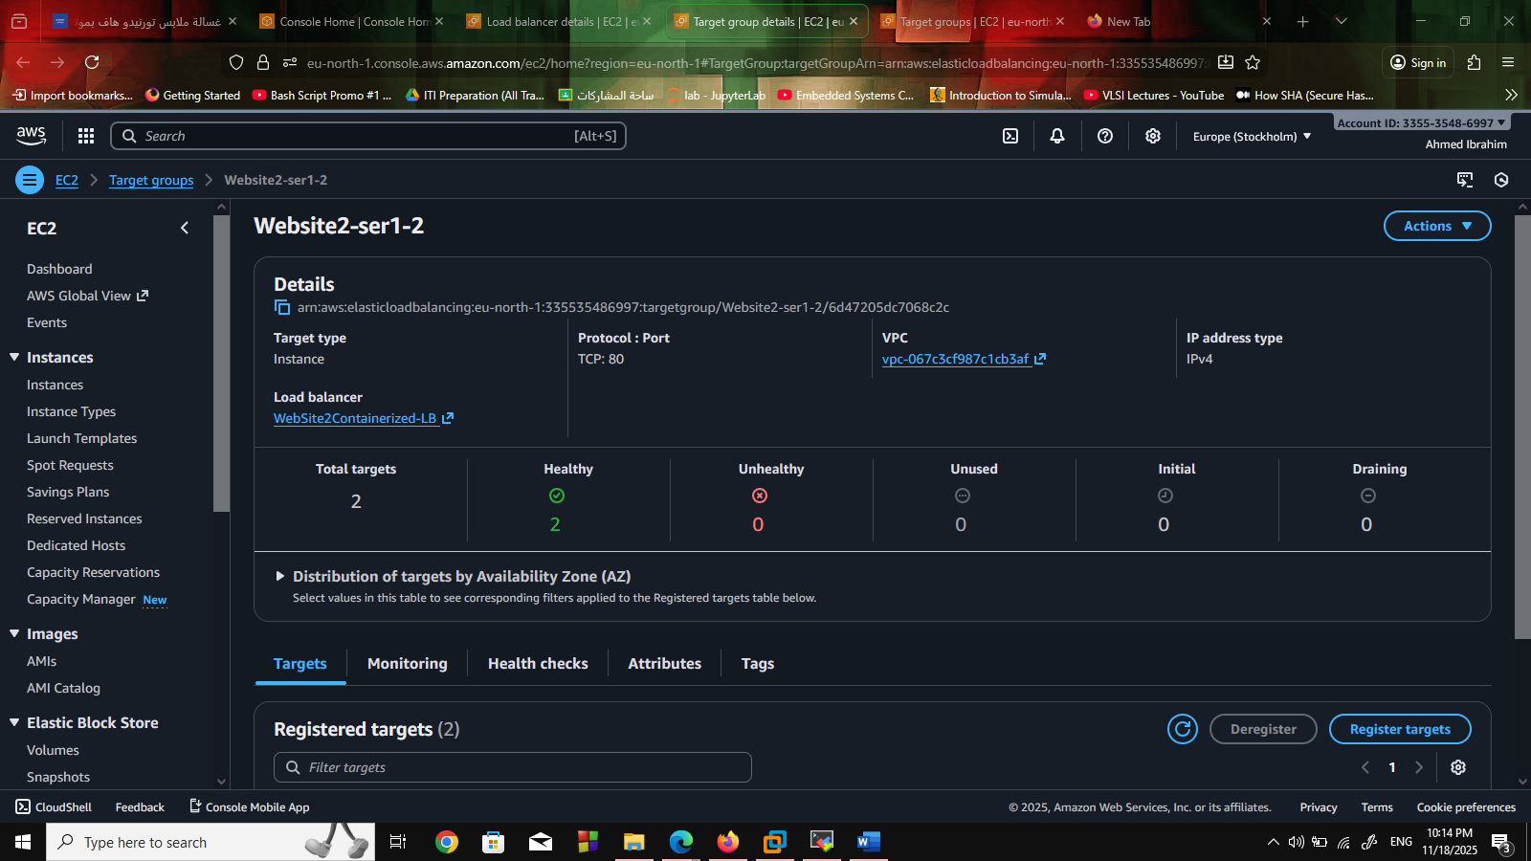

Load Balancer:

Listeners:

EC2 Configuration:

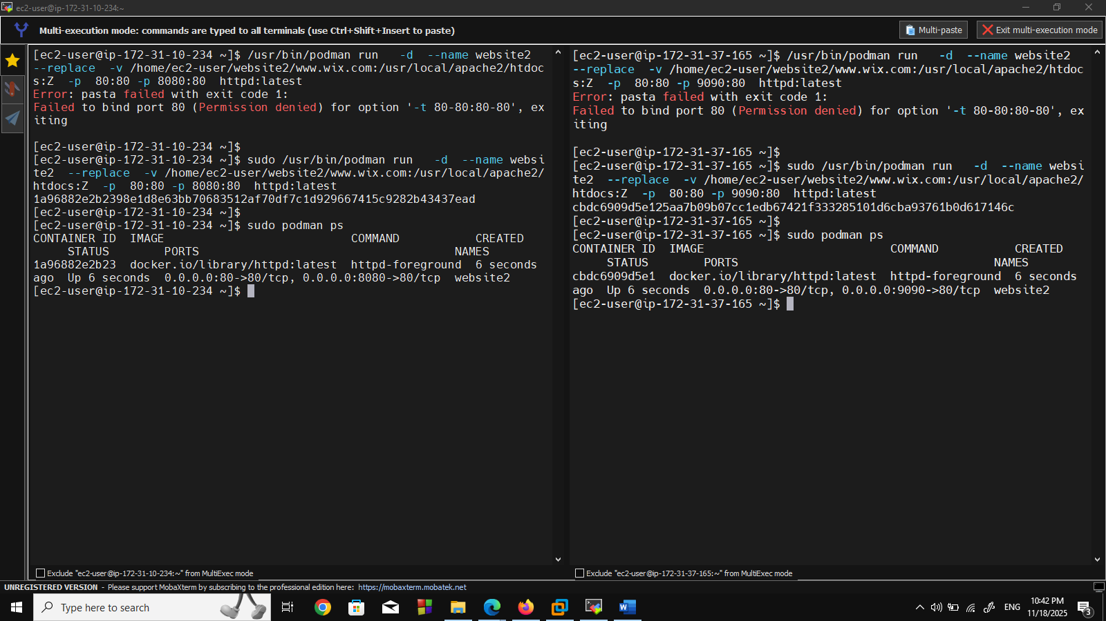

Visiting the Containerized Website:

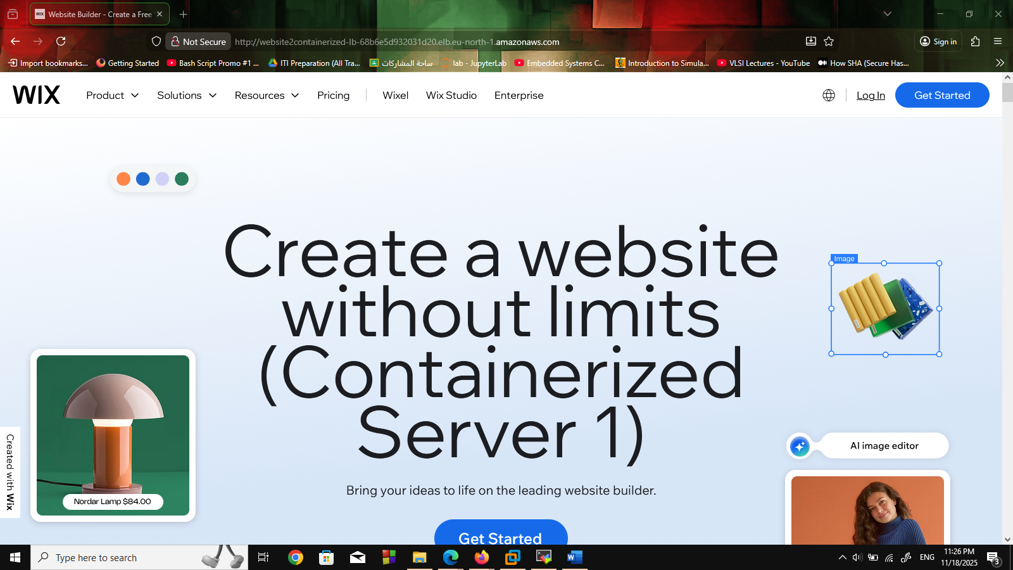

Using Port numbers:



